|  |  |
| --- | --- |
| Name | Shaunak Deshpande |
| Division | IC-C |
| Roll number | 39 |
| Batch | 2 |
| GR Number | 11911180 |

CN Lab 3: Multiplexer and Demultiplexer

Multiplexer:

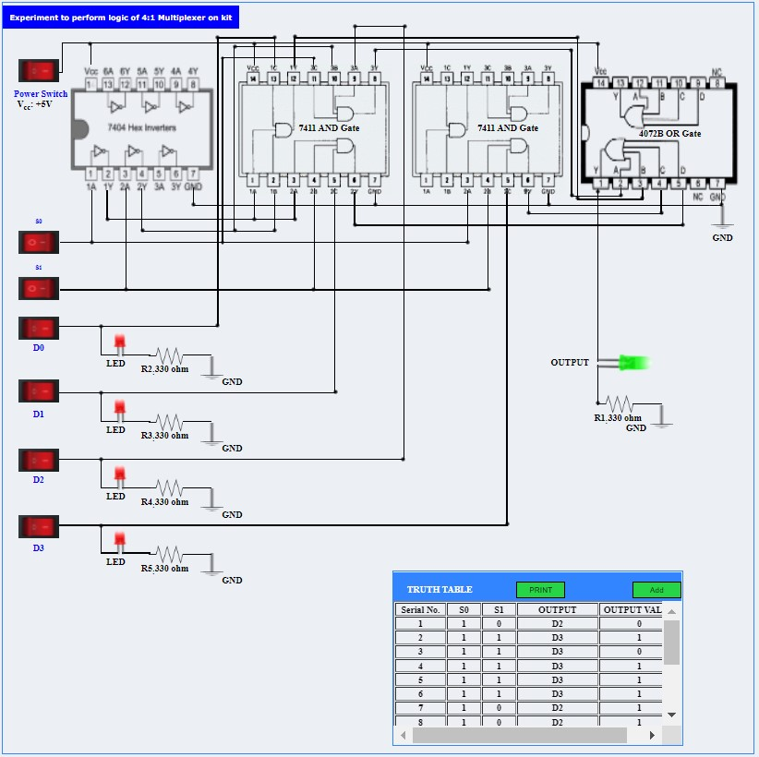

Demultiplexer:

